Brief CV, Dr Ashley Mills, ashley@ashleymills.com, +44(0)7825608771

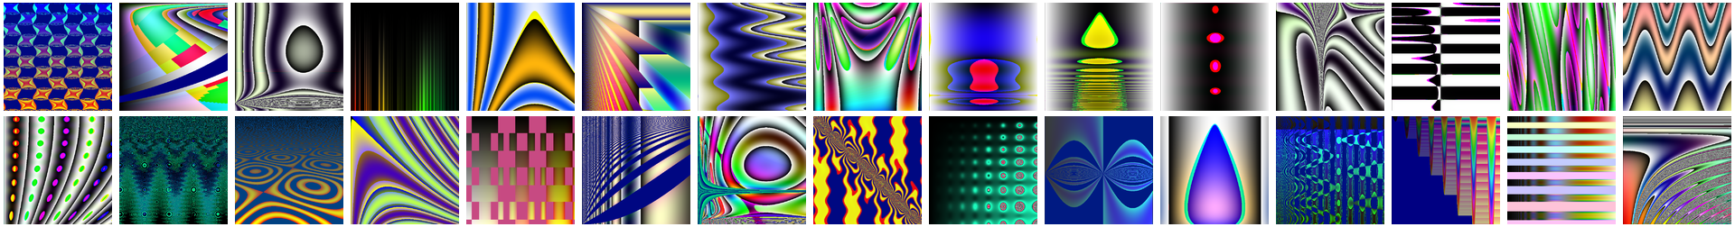

Employment

Research Associate, University of Kent, July 2016 - Present

I am the technical lead on a pollution monitoring project designing, building, and maintaining the data acquisition hardware, server backend, and visualisation elements.

Director, Technology for Good CIC - August 2016 – March 2018

Technology for Good was incorporated to work on problems of environmental and societal import and carried out pro-bono technical work for a variety of social enterprises.

Sessional Lecturer / Makerspace Technician, University of Kent, School of Computing, December 2015 – December 2016

Lecturing for IoT, Erlang, and People and Computing modules. Co-management of makerspace. Construction of IoT prototypes for external stakeholders.

Data Scientist, Holiday Extras Ltd. January 2015 - April 2015

Analysed PPC data to assess bidding strategy and constructed a tool to aid decision making. Responsible for maintaining adwords scraper.

Director, Noisy Atom Ltd – September 2014 – August 2016

Noisy Atom is an IoT solutions company. Consulted on IoT projects for external clients. Re-worked PCBs for external client. Performed R&D on IoT product development.

M2M (Machine to Machine) Specialist, Vodafone Group R&D, March 2011 – September 2014

M2M product development lead. Covering high level design, systems integration, hardware prototyping, and embedded software development. Rapidly developed IoT prototypes for people across the business. Management of stakeholders, contractors, suppliers, and budget of ~200K.

Radio Systems Engineer, Vodafone Group R&D + University of Bath, March 2007 - March 2011,

Lead developer on LTE link and system level simulator. Research focused on scheduling mechanisms to mitigate inter-cell interference. Managed R&D compute cluster. Lead author of three peer-reviewed publications. Author on three granted patents.

Computational Neuroscience Researcher, Graz University of Technology, October 2005 - August 2006,

Software development and research. Research focused on the representation of time in the cerebellum during delayed-conditioning tasks. Biologically accurate models of cerebellar circuits were developed and experiments conducted.

Nuffield Bursary Researcher, The University of Birmingham, Summer 2003,

Software development and research. Research focused on induction of symbolic structures in networks of spiking neurons. Modelling of recurrent networks of spiking neurons. Second author on two peer-reviewed publications.

Skills

Programming

15+ years experience in c, c++, java, matlab, R, python, sh, javascript, etc. Extensive modelling of physical systems. Implementation of many combinatorial and other optimisation routines. Ability to work from industry specifications to produce compliant software. Custom network clients and servers. Produced, exhibited, and sold computer art based on genetic algorithms.

Analysis

15+ years experience using Matlab for statistical and parametric analysis. Creation of custom visualisation tools. Visualization of high dimensional and complicated data sets. Working with very large data sets across clusters of computers.

Print

LaTeX, Docbook, Word. Experience authoring of peer reviewed scientific articles (7), patents (3), tutorials (20+). Reviewer for IEEE journals and conferences. Written hundreds of blog articles attracting tens of thousands of web hits.

Software / devops

15+ years of Unix experience. Installation and configuration of nginx, lighttpd, haproxy, postfix, spamassassin, ipfw, iptables, etc. Maintained personal web and mail server for family. Maintained Vodafone R&D compute cluster.

Communications

Extensive presentation and public speaking. International project involvement, both academic (for example FP7 projects) and industrial collaborations. Attendance and contribution to industry standards meetings and other forums. Three month secondment at NII, Tokyo, Japan.

Education

The University of Bath, School of Computer Science:

Doctor of Engineering (EngD). Plus one prize for best application of systems engineering. Graduated 2011.

The University of Birmingham, School of Computer Science:

MSc Natural Computation (Distinction). Plus 2 prizes for academic excellence. Graduated 2005.
BSc Computer Science (Class 1 with Honours). Plus 5 prizes for academic excellence. Graduated 2004.

